# Feasibility of a hydraulic powered anthropomorphic prosthetic hand

Authors: Kevan Vuong & Andrew Robinson

Supervisor: Dr. Chao Chen

### Summary

Powered prosthetic hand development currently focuses heavily on electromechanical actuation or employing novel soft actuators. However, this has left traditional methods of actuation such as hydraulic fluid power under-researched. Large-scale fluid power has been well researched for industrial purposes, and if scaled down, the benefits it provides for industrial use has the potential to also benefit prosthetic design.

Construction and development of a hydraulic actuated prosthetic hand was successfully completed to compare experimental values with rival actuators and biological capabilities. It was anthropomorphically designed, including a tendon-based power transmission. A wearable system was not considered at this stage due to both time and budget constraints.

The prototype provided approximately 10.5kg of grip force (power grasp) at 18 bars of pressure, whilst allowing complete trajectory following albeit with slight response delay and steady-state error. Unfortunately, the system was pressure limited by the valves, not the cylinders, which halved the effective working pressure suggesting that a 20kg grip force was attainable. Furthermore, modelling of the system suggested considerable losses which resulted in significant inefficiencies in our construction.

Statistical comparison between the prototype hydraulic hand and the benchmarks proved that hydraulic actuation for prosthetic solutions is a viable, if not desirable method of actuation. The advantages of fluid power have the potential to provide a durable prosthesis with the capability of performing all activities of daily living as well as physically demanding work.

### Table of Contents

Summary 2

Table of Contents 3

Table of Figures 4

List of Tables 5

1. Introduction – Overview 6

1.1 Motivation & Aims – Research gap (general) 7

2. Evaluation of hydraulic actuation 9

3. Concept development of a full hand prosthesis 10

4. Design Requirements 11

5. Final design 12

5.1 Hydraulic design 12

5.2 Electrical Design 13

5.3 Structure 14

5.4 Control 17

5.5 Software 17

5.6 Controller Tuning Process 18

6. Model Development 19

6.1 Force Estimation 19

6.1.1 Assumptions 19

6.1.2 Finger Model Analysis 20

6.2 Finger Angle to Cylinder Position Mapping 23

7. Functional evaluation 25

7.1 Precision 25

7.2 Grip force 31

7.3 DoF and Range of Motion 33

8. Discussion 36

8.1 Suggestions for improvements 37

9. Acknowledgement 37

10. References 38

11. Appendices 41

### Table of Figures

Figure 1 (Left) The power grasp (Yokokohji et al. 2005), (Right) The cylindrical power grip (Love, Lind, and Jansen 2009) 7

Figure 2 (Left) Ottobock body powered hook (Ottobock. 2018) vs. (Right) DEKA externally powered prosthesis (Sanchez 2018) 10

Figure 3 Joint angles were taken between the two bones connected to the joint, on the palmar side of the hand 11

Figure 4 Architecture for the mechanical drive system based on (Durfee, Xia, and Hsiao-Wecksler 2011) 12

Figure 5 Hydraulic circuit block diagram 12

Figure 6 Simplified hydraulic schematic 13

Figure 7 Prototype board circuit design 14

[Figure 8 Initial print (Left), Revised finger joints (Right) 15](https://d.docs.live.net/5c6cad01ee5fb88a/Documents/2018%20FYP/Final%20Report%20Feasibility%20of%20a%20hydraulic%20powered%20anthropomorphic%20prosthetic%20hand.docx#_Toc527719543)

Figure 9 (Left) Self designed model vs (Right) Hanson Robotics model (Morales 2018) 15

Figure 10 Prototyped cylinder array 16

Figure 11 Cylinder with potentiometer mount and potentiometer attached 17

Figure 12 Microcontroller communications flowchart 17

Figure 13 Classical PID controller 18

Figure 14 Rigid Body Assumption 19

Figure 15 Finger orientation for analysis (left) and variable names for analysis (right) 20

Figure 16 Theoretical individual finger force contribution to dynamometer grip test 22

Figure 17 Theoretical dynamometer grip force with change in pressure 22

Figure 18 Cable angle locations for friction loss 23

Figure 19 Experimental linear to finger angle data for the cylinder controlling the little fingers MCP joint 23

Figure 20 Linear position to MCP joint angle conversion formula for index finger 24

Figure 21 Linear position to PIP joint angle conversion formula for index finger 24

Figure 22 Error and System Response of Cylinder 3 following leap motion controller 26

Figure 23 Error and System Response of Cylinder 0 following leap motion controller 27

Figure 24 Error and System Response of a single cylinder follow with a large step input 28

Figure 25 Error and System Response of a cylinder follow with a ramp input with all cylinders moving 29

Figure 26 Error and System Response of a single cylinder follow with a ramp input 29

Figure 27 Error in degrees for all cylinders following the Leap motion controller input 30

Figure 28 Theoretical and Experimental Cylinder Retraction Force 31

Figure 29 Theoretical and Experimental Dynamometer power grasp measurement 32

Figure 30 Dynamometer Power Grasp Experiment Setup 33

Figure 31 Linear position to MCP joint angle conversion formula for index finger 41

Figure 32 Linear position to PIP joint angle conversion formula for index finger 42

Figure 33 Linear position to MCP joint angle conversion formula for index finger 42

Figure 34 Linear position to PIP joint angle conversion formula for middle finger 43

Figure 35 Linear position to MCP joint angle conversion formula for index finger 43

Figure 36 Linear position to PIP joint angle conversion formula for ring finger 44

Figure 37 Linear position to MCP joint angle conversion formula for index finger 44

Figure 38 Linear position to PIP joint angle conversion formula for little finger 45

Figure 39 Complete hydraulic schematic 47

### List of Tables

Table 1 Mean and Standard Deviation of Hand Grip Strength in kilograms, for men and women, presented in ascending age groups (Massy-Westropp et al. 2011) 8

Table 2 Contemporary Upper Limb Prostheses Comparative Statistics (Riet et al. 2013) 8

Table 3 Finger joint range of motion [21] 12

Table 4 Summary of design requirements [13, 34] 12

Table 5 Single Analysis variable values 21

Table 6 Linear error corresponding to 1° 25

Table 7 Figures of gestures using the hydraulic hand 33

Table 8 Fist Forming Times 36

Table 9 Finger Dimensions for Model Analysis 46

### Introduction – Overview

There are over one million people worldwide who have undertaken some measure of upper limb amputation (Mata Amritanandamayi, Udupa, & Sreedharan, 2018), with a projected one million upper-limb amputees to be living in the United States alone by the year 2050 (Perry et al., 2018). As a result, there is a continually increasing need for functional prosthetic limbs to assist amputees with activities of daily living, as well as physically demanding work.

Functionality and aesthetic design are most often seen as the two major decision-making factors when choosing whether or not to use a prosthetic (Piazza et al., 2017). However, studies have found that of these two deciding factors, high grip power, grasp versatility, resilience and power autonomy, are generally the dominant design parameters (Piazza et al., 2017; Resnik & Klinger, 2017). This is due to the important role that practicality and functionality play in not only being able to perform specific activities and restoring normality to a person’s life, but also improving the possibility of being reinserted into a job (Proaño-Guevara, Procel-Feijóo, Zhingre-Balcazar, & Serpa-Andrade, 2018). Additionally, a study found that of all adult amputees who were employed prior to the loss of an upper limb, of the percentage that returned to work, the lowest returning percentage were those who worked in physically demanding environments where the prosthetic solution they were provided with was either unsuitable or too difficult to operate given their circumstances (Millstein, Bain, & Hunter, 1985).

The demand for a highly functional prosthesis is supported by the adoption and rejection rates of current prostheses. Studies have found that between 17% to 80% of people with major upper limb amputation entirely reject the use of a prosthesis because the functional advantage or cosmesis did not outweigh the inconvenience of the prosthesis (Gailey et al., 2017; Proaño-Guevara et al., 2018; Resnik & Klinger, 2017). A recurring theme presented by amputees is the desire for enhanced strength or grasp force for both myo-electric devices (Hashim, Abd Razak, Abu Osman, & Gholizadeh, 2018; Piazza et al., 2017; Proaño-Guevara et al., 2018) and body powered devices (Ayub, Villarreal, Gregg, & Gao, 2017; Mona Hichert, Abbink, Kyberd, & Plettenburg, 2017). For example, for the voluntary closing body powered prosthesis known as the Hosmer Soft Hand, patients had to exert over 131N of cable force in order to achieve a mere 15N pinch force (M. Hichert, Vardy, & Plettenburg, 2018). A prosthesis powered by dielectric actuators could only achieve 35-97N output force (El-Hamad, Ahmad, & Ishak, 2017), and a novel pneumatically powered soft actuator could only achieve 0.46N at 5 bar of pressure (Mata Amritanandamayi et al., 2018). To illustrate the issue, it was found that to complete typical activities of daily living, a minimum pinch force of 68N is required. Additionally, a typical anatomically intact male hand can exert 450-470N worth of force during flexion (Massy-Westropp, Gill, Taylor, Bohannon, & Hill, 2011). Thus, it is clear that there is a significant gap in strength between current prostheses and anatomically intact hands, and consequently a need for more powerful and stronger prostheses.

Furthermore, Resnik and Hashim have found that weight is also a significant contributor to prosthesis adoption (Hashim et al., 2018; Resnik & Klinger, 2017). A majority of externally powered prostheses make use of electrical servo motors in order to actuate the appendages. These prostheses are generally very complex and heavy due to the need for extensive gear trains or drive train mechanisms, and in some cases the placement of a servo motor at every rotational joint (Pai et al., 2016). For example, the Modular Prosthetic Limb developed by DEKA weighs approximately 4.8kg with its battery attached (Leal-Naranjo, Ceccarelli, & Torres-San Miguel, 2017). In comparison, an upper limb of a 75kg person typically weighs 3kg (Abayasiri, Madusanka, Arachchige, Silva, & Gopura, 2017). Using heavy and unwieldy prostheses can result in significant musculoskeletal issues such as excessive discomfort on the stump and noticeable shoulder strain, which if sustained for extended periods of time may develop into injuries (Abayasiri et al., 2017; Schweitzer, Thali, & Egger, 2018).

Additionally, the distribution of the weight along the arm is equally important. Weight from heavy servo motors and other supporting components, especially towards the extremities of the body negatively impacts the usability of the device. Waters and Mulroy found that an additional weight of 2kg on each foot of a healthy adult results in a 30% increase in oxygen uptake, whilst over ten times that amount on the torso has little impact (Waters & Mulroy, 1999). Extending this to the upper limb demonstrates that a poor weight distribution often provided by externally powered prostheses is often hugely detrimental to the physical health and comfort of the patient. For example, the TRS i-Limb (a commercially available prosthetic hand) weighs 0.63kg with a centre of gravity that is fairly distal in comparison to an anatomically intact hand due to the location of the actuators ("Touch Bionics Product Catalogue," 2015). It was found that this layout of components caused significant discomfort to the stump and noticeable shoulder strain during extended use (Schweitzer et al., 2018).

Therefore, to increase usability and reduce prostheses rejection, alternative designs and actuation methods need to be explored.

#### Motivation & Aims

There is a clear need for stronger prosthetic actuators (Riet, Stopforth, Bright, & Diegel, 2013). The average grip strength for men and women vary considerably, however it should be noted that for males and females aged 20 years all the way to 70 years old, the lowest average grip strength is 19kg (Massy-Westropp et al., 2011), or approximately 190N of force. For reference, all further mentions of grip strength will be relating to the power grasp (or cylindrical power grip (Love, Lind, & Jansen, 2009)) – a grip that uses all the fingers and the palm with the thumb in the opposed position.

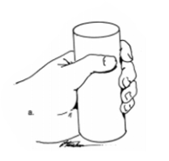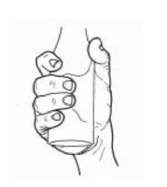

Figure 1 (Left) The power grasp (Yokokohji, Muramori, Sato, & Yoshikawa, 2005), (Right) The cylindrical power grip (Love et al., 2009)

Table 1 Mean and Standard Deviation of Hand Grip Strength in kilograms, for men and women, presented in ascending age groups (Massy-Westropp et al., 2011)

|  |  |  |  |  |  |
| --- | --- | --- | --- | --- | --- |
| **Men** | | | **Women** | | |
| **Age** | **Right** | **Left** | **Age** | **Right** | **Left** |
| 20 to 29 | 47(9.5) | 45(8.8) | 20 to 29 | 30(7) | 28(6.1) |
| 30 to 39 | 47(9.7) | 47(9.8) | 30 to 39 | 31(6.4) | 29(6) |
| 40 to 49 | 47(9.5) | 45(9.3) | 40 to 49 | 29(5.7) | 28(5.7) |
| 50 to 59 | 45(8.4) | 43(8.3) | 50 to 59 | 28(6.3) | 26(5.7) |
| 60 to 69 | 40(8.3) | 38(8) | 60 to 69 | 24(5.3) | 23(5) |
| 70+ | 33(7.8) | 32(7.5) | 70+ | 20(5.8) | 19(5.5) |

To illustrate the issue, a considerable number of prosthetics do not achieve more than 100N of grip force. Of the seven different prostheses that Riet tested, only two achieved more than 100N of grip force, with the highest measuring 140N (Riet et al., 2013). This is 26% lower than the left-hand strength of a 70+ year old female.

Table 2 Contemporary Upper Limb Prostheses Comparative Statistics (Riet et al., 2013)

|  |  |  |  |  |  |  |  |
| --- | --- | --- | --- | --- | --- | --- | --- |
|  | **i-limb ultra** | **BeBionic3** | **Michelangelo** | **SmartHand** | **Vanderbilt University Hand** | **Southhampton Hand** | **MARCUS** |
| Grip Strength – Power Grip (N) | 136 | 140 | 70 | 36 | 50 | - | - |
| Closing Speed – Power Grip (sec) | 1.2 | 1 | - | 1.5 | 0.3 | - | - |
| Grip and Hand Positions | 11 | 14 | 7 | - | 8 | 6 | 3 |
| Control | 2 Channel Myoelectric | 2 Channel Myoelectric | 2 Channel Myoelectric | Myoelectric | Myoelectric | Myoelectric | Myoelectric |
| Actuators | DC Motors | DC Motors | DC Motors | DC Motors | DC Motors | DC Motors | DC Motors |
| Touch Sensors | No | No | No | Pressure | No | Pressure, slip, temperature | Pressure, slip |
| Cost | 40,000 | 35,000 | 75,000 | - | - | - | - |

Rice found that for activities of daily living, such as opening jars, to spraying aerosols, the grip strength required to successfully complete these activities ranged from 10N to over 220N (Rice, Leonard, & Carter, 1998). With current iterations of prosthetic design, it is evident that there will be a significant number of activities that upper limb amputees will be unable to complete without assistance, let alone performing physically demanding tasks.

### Evaluation of hydraulic actuation

Hydraulic power is a well-known yet rarely explored method of actuation. This could be due to the high cost of the equipment and components required to construct hydraulic circuits stemming from the low tolerances required for high pressure systems. However the benefits that hydraulics can provide to the prosthetics field are numerous.

Fluid power has the potential to generate extremely large forces with smaller and more flexible configurations than traditional electromechanical devices. Durfee, Xia and Hsiao-Wecksler modelled micro hydraulic cylinders, and concluded that at a nominal pressure of 6.9MPa (1000psi), a single hydraulic cylinder with a mere 4mm bore can output up to 87N worth of force (Durfee, Xia, & Hsiao-Wecksler, 2011). Comparatively, a similarly powerful electric linear actuator would be significantly larger. If these cylinders were to be implemented, a considerable number of them would be able to fit in the space that would otherwise be taken up by a servo array, potentially removing the need for under-actuation and reducing the complexity of common prosthetic mechanical systems.

Hydraulic powered actuators also do not require the typical power transfer systems in order to operate (Foglyano et al., 2015). It was found that for a 100W mechanical system, an electromechanical system is predicted to weigh 428g. A hydraulic system with equivalent mechanical output has the potential to weigh significantly less. For example, a system operating at 0.69MPa (100psi) is estimated to weigh 625g, at 3.45MPa (500psi) it is estimated to weigh 125g and at 6.9MPa (1000psi) it is estimated to weigh a mere 63g (Durfee et al., 2011). This gives significant flexibility in the design to maximise the desired weight to power ratio whilst also providing a significant weight reduction which can aid heavily in the comfort and usability of the device.

An additional advantage of fluid power is the ability of power to be transported through flexible hosing which can be snaked over moving joints and placed in locations that would otherwise be impractical for electrical motors. This characteristic provides great flexibility in component placement such as placing the hydraulic cylinders on the proximal joints (Durfee et al., 2011), and the other heavier components such as the pump, valves and battery may be kept on the torso where they cause a considerably lesser strain on the body (Foglyano et al., 2015). Furthermore, this flexibility can be leveraged for numerous additional benefits. By being able to choose the location of the actuators, they can be optimised for maximum benefit. Placing the actuators away from the joints of the fingers and closer to the shoulder aids in reducing the rotational inertia (Leal-Naranjo et al., 2017) which allows greater control over the arm and reduced power requirements in order to operate it. This also allows the end effector or the hand to be minimised to further reduce the weight (Semasinghe et al., 2018), as a prosthetic hand weighing 0.5kg or more tends to lead to overexertion (Proaño-Guevara et al., 2018). Power then can be transmitted to the distal joints via tendon or cables – a technique used often in prosthetics to gain similar benefits (Love et al., 2009).

Lastly, hydraulic systems are shown to have very high precision control, especially when compared to pneumatic or electric systems (Nath & Durfee, 2017). Hydraulic fluid, being essentially incompressible is extremely valuable to precision control as it does not store energy and it is also a continuous medium. Whereas electrical motors have discrete movements for precision control, and pneumatics are compressible which lead to sudden movements and poor precision control.

There is a clear need for stronger and more powerful, yet lighter and more robust prosthetic devices, which can be catered to by hydraulics. These benefits combined with its flexible component configuration as well as its force-to-weight ratio have the potential to develop a revolutionary prosthetic design. It will be another step in the direction to allow amputees and similarly disadvantaged persons to mitigate the adverse effects of upper limb loss and enable them to retain or regain their standard of living.

### Concept development of a full hand prosthesis

There is a strong motivation to develop an anthropomorphic style prosthetic hand. Aesthetic or degree of anthropomorphism is often seen as a critical characteristic of a prosthetic system as it plays a crucial role in the psychological wellbeing and social acceptance of amputees (Piazza et al., 2017). This is reflected in both the usage gap (Hashim et al., 2018) and rejection rates (Gailey et al., 2017) between externally powered prostheses and body powered prostheses, as body powered prostheses are simple and purely functional in design whereas externally powered prostheses generally have the flexibility to pursue more anthropomorphic designs. Whilst developing an anthropomorphic and anatomically correct system based on the human musculoskeletal system is challenging (Proaño-Guevara et al., 2018), there is no reason to develop a prosthetic system if adoption rates will be low.

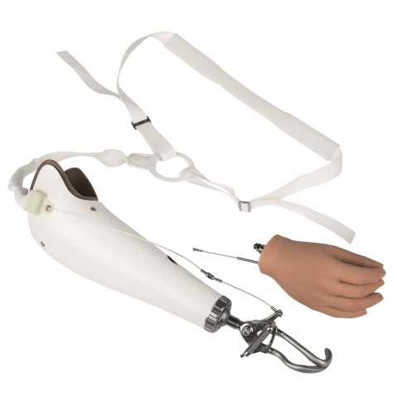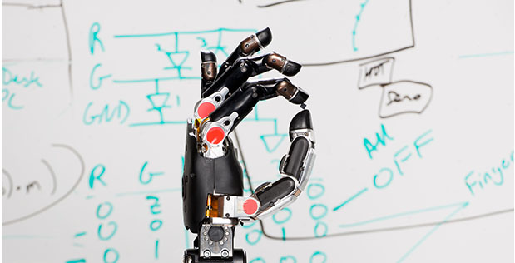

Figure 2 (Left) Ottobock body powered hook (Ottobock., 2018) vs. (Right) DEKA externally powered prosthesis (Sanchez, 2018)

A significant characteristic of anthropomorphic design is the use of tendon-based actuation. Human hands are based on extrinsic actuation, where the muscles are located in the limb prior to the joint, and then connected via semi-compliant cord (Love et al., 2009). Tendon-based hands have the advantage of locating actuators away from the hand, which allows miniaturisation of the end effector and simplification of operation. However, there are also significant drawbacks. Accurately modelling joint kinematics becomes difficult with tendon-based actuation, and considerable efficiency losses are introduced such as friction losses between tendon and tendon enclosures (Proaño-Guevara et al., 2018; Semasinghe et al., 2018). Nevertheless, tendon-based actuation is ideal as it allows the use of additional and larger actuators to both better control and strength.

A further defining characteristic of the biological hand is that it has 22 degrees of freedom, not including the wrist (Organ, 2008). To individually control all degrees of freedom would require a large number of actuators and would pose a challenge in terms of component layout as well as control (Mottard, Laliberté, & Gosselin, 2017). However, biological systems generally do not allow independent motion of every individual joint (Baril, Laliberté, Guay, & Gosselin, 2010). Employing under-actuation into prosthetics takes advantage of this fact, allowing movements to be encoded into physical or hardware design (Gailey et al., 2017) as well as providing side-benefits such as space and weight conservation from the reduction in the number of actuators (Grioli, Catalano, Silvestro, Tono, & Bicchi, 2012).

Thus, the ideal prosthetic device takes into account all of the aforementioned factors – anthropomorphic design, tendon-based actuation as well as under-actuation. Successfully incorporating these three components into a powerful, controllable, and durable prosthesis could potentially revolutionise the current state of the prosthetic industry.

### Design Requirements

There are several key design requirements necessary to demonstrate a suitable prosthetic design to help significantly improve amputees quality of living. These include a variety of different criteria, based on criteria established in both (Liu, Yang, Jiang, & Liu, 2015) and (Love et al., 2009).

Love established concise values for the range of motion for the individual joints on the hand (Love et al., 2009). Only the metacarpophalangeal joints (MCP) and proximal interphalangeal joints (PIP) are required as under-actuation of the distal interphalangeal joint results in the joint being uncontrollable.

Liu created a synthetic framework that can be used to evaluate the anthropomorphic characteristics of prosthetic hands, including criteria such as size, grasp force and grasp speed. 400N was advised as the optimal power grasp force, however 200N was chosen as it was the lowest average grip strength for healthy human hands (Massy-Westropp et al., 2011).

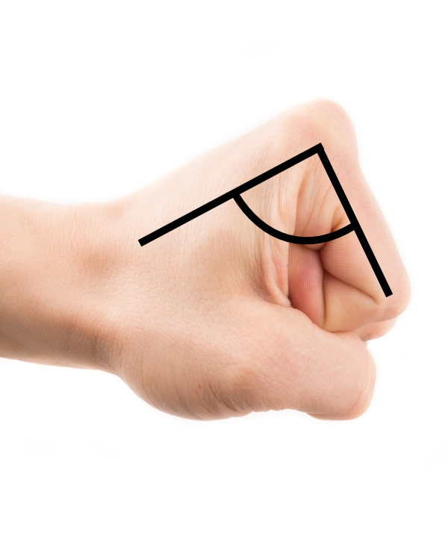

Figure 3 Joint angles were taken between the two bones connected to the joint, on the palmar side of the hand

Table 3 Finger joint range of motion [21]

|  |  |  |  |  |
| --- | --- | --- | --- | --- |
|  | **Index** | **Middle** | **Ring** | **Little** |
| MCP | 90° - 210° | 90° - 210° | 90° - 210° | 90° - 210° |
| PIP | 70° - 180° | 70° - 180° | 70° - 180° | 70° - 180° |

Table 4 Summary of design requirements [13, 34]

|  |  |
| --- | --- |
| **Property** | **Design requirement** |
| Size | ~198x90mm |
| Grasp Force | >200N |
| Grasp Speed | 172°/s |
| Position error | 1° |

### Final design

The final structure of the prototype system was based on (Durfee et al., 2011), who developed a hydraulic system for an orthotic device.

Motion Controller

Computer

PWM Driver

Servo motor

Valve

Conduit

Cylinder

Pump

Figure 4 Architecture for the mechanical drive system based on (Durfee et al., 2011)

All components prior to the valve represent the power supply and control components. The conduit block represents the power transmission line, and the cylinder block represents the actuator.

#### Hydraulic design

The hydraulic requirements for the system is very simple. It is a basic pump, actuator, and directional control valve configuration. The block diagram of this system can be found in Figure 4, a simplified schematic in Figure 5, and the complete schematic in Appendix C.

Pump

Pump

Valves

Valves

Conduit

Conduit

Cylinder

Cylinder

Figure 5 Hydraulic circuit block diagram

The system employs a hydraulic gear pump with a 1.1kW motor, a 45L reservoir and a maximum rated pressure of 45 bar. Oil is transported via nylon hosing to a secondary hydraulic valve array, which allows proportional control of fluid flow. This then leads to the cylinders which have a 3in stroke and a 3/8in bore.

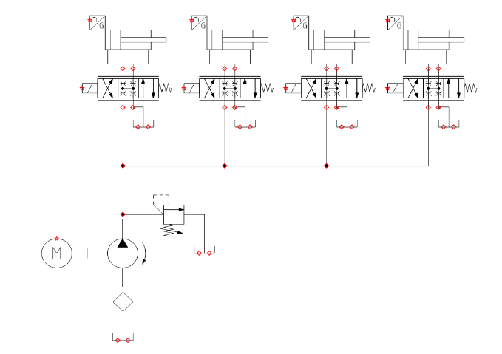

Figure 6 Simplified hydraulic schematic

The system has been pressure limited to a working pressure of 18 bar, due to the operational constraints of the hobby grade hydraulic valves.

#### Electrical Design

The electrical circuits were designed and implemented on prototyping board. There were two distinct circuits that were constructed, one that operates at 24V, and on that operates at 5V.

The 24V circuit was a simple switch which supplied power to the control interfaces of the pump. These were all bang-bang actuation solenoid valves, which pulled around 2A during operation.

The 5V circuit is shown in Figure 7 houses the PSoC as well as the connections to all the servo motors, and the potentiometers. As two PSoCs were required, two of these circuits had to be built. Additional 20W power supplies had to be used as the power supplied by USB was insufficient to power all 8 servo motors controlling the hydraulic valves.

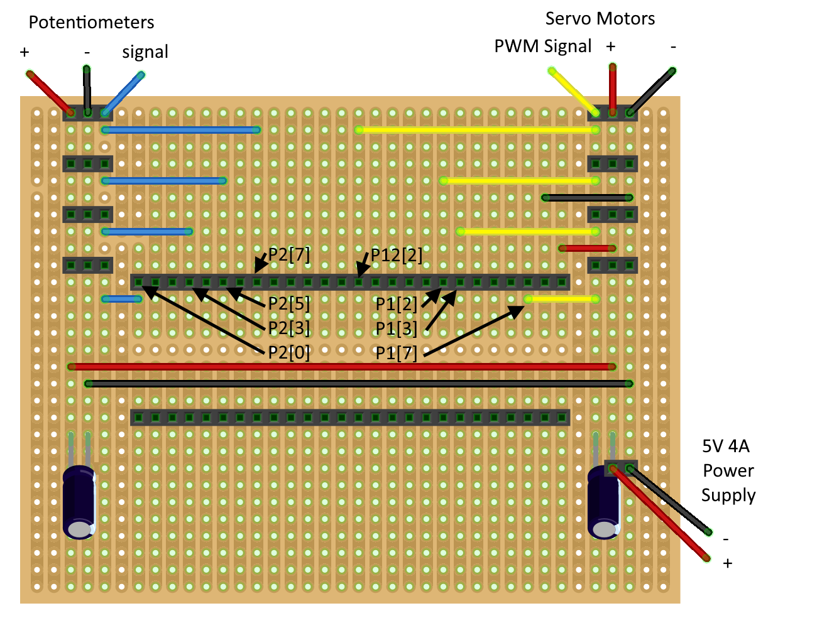

Figure 7 Prototype board circuit design

#### Structure

Initially we had opted to develop our own prosthetic hand structure so that we could optimise it for a hydraulic actuation method. The model would be based off Thieme’s Atlas of Anatomy (Organ, 2008) which provided in-depth insight into the structure of the upper limb. We had decided to model all 22 DoF initially, which led to an initial design seen in Figure 8. After the initial print, we then determined that we would remodel the joints such that they were designed as single degree of freedom joints for ease of actuation (Figure 9 left). The metacarpal bones were designed to be separate such that if we wished to implement the abduction and adduction of fingers, there would be room for the actuators in the anatomically correct locations. We determined however that achieving anatomically correct abduction and adduction would be impossible with the components we could acquire if we wished to retain complete hydraulic actuation.

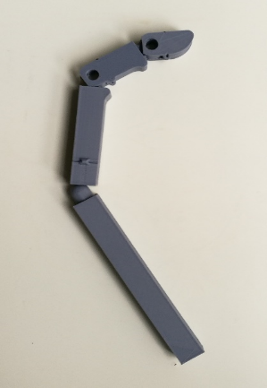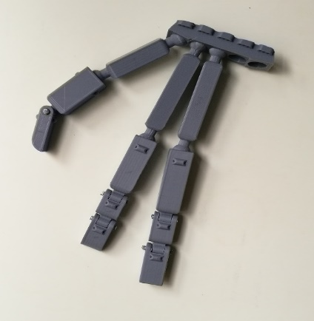

Figure 8 Initial print (Left), Revised finger joints (Right)

However after much deliberation, we decided that designing our own prosthetic arm would take too much time for the project duration, and thus opted to use and adapt an externally made prosthetic hand for our actuation method (Figure 9 right). The model we decided to base our prosthesis off was made and developed by Hanson Robotics for the Sophia Robot Project (Morales, 2018). Modifications to the model were required to suit our actuation method, which included removing one linkage from the under-actuation assembly and allowing externally mounted elastics.

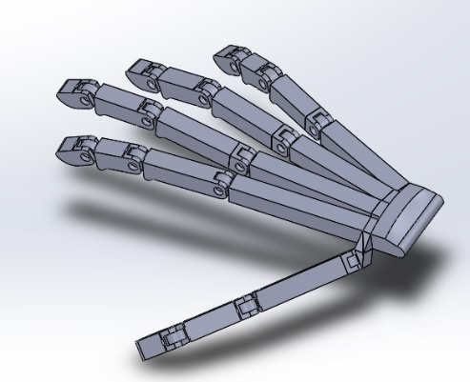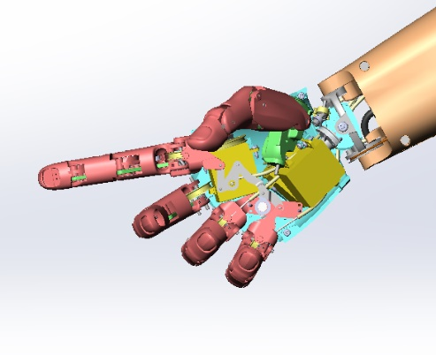

Figure 9 (Left) Self designed model vs (Right) Hanson Robotics model (Morales, 2018)

The prosthesis was fabricated at 1.5 times the size of the model, to both increase the ratio between linear wire motion and angular movement, as well as scale the hand to be more proportional to the size of the actuators being used. Each part of the hand was fabricated using a fused disposition modelling (FDM) 3D printer, using polylactic acid (PLA) filament material. PLA was chosen for its balance with ease of printing and post processing, as well as structural integrity.

Due to time constraints, a forearm and wrist were not constructed. Thus, all components of the prototype were mounted to a baseboard in order to create a stable base and simulate a fixed wrist without space constraints.

The chosen actuation system for the fingers followed Kontoudis’s recommendation in using elastomeric materials to perform digital extension, whilst using cables attached to the actuators for flexion (Proaño-Guevara et al., 2018). For the elastomeric component, rubber bands were stretched externally over the fingers similar to the HyPro prosthetic hand (Semasinghe et al., 2018). This allows for extension as when the actuators extend, slack appears in the cable which is then picked up by the elastic component. 0.5mm braided steel wire was used to transmit the force from the actuators to the digits, which whilst has no elasticity unlike tendons, simplify control strategies significantly. Whilst there are inefficiencies employing a cable transmission (mainly from friction) (Mona Hichert et al., 2017; Semasinghe et al., 2018), given our actuation method these losses seemed to be insignificant for demonstrative purposes. Furthermore, using cables allow pulleys to be incorporated into design to create mechanical advantage, providing a significant advantage over direct drive designs (Mottard et al., 2017). A 2:1 pulley system was introduced to the actuators controlling the metacarpophalangeal (MCP) joint, resulting in a mechanical advantage of 2 whilst at the same time doubling the linear movement required by the actuator. This served two purposes, both increasing output force and increasing control resolution.

An additional wire guide and mounting piece were designed and printed to attach the hand to the base board. The wire guide serves to keep the steel braided wire for the cable transmission separated and limit the amount of wear caused by wire-on-wire friction. A limitation of the prototype transmission system was the way cables were tensioned. Zip-ties were employed for their affordable ratchet locking mechanism and were successful until excessive force was transmitted through maximum load testing.

Each part was printed at 0.2mm layer height, with four 0.4mm walls and 25% infill. This ensures a strong finished product and that will not break under the full load of the hydraulic cylinders.

The cylinders were mounted to a 10mm plywood board in two rows of five cylinders, with the rear cylinders raised slightly to prevent the wires interfering with each other as shown in Figure 10.

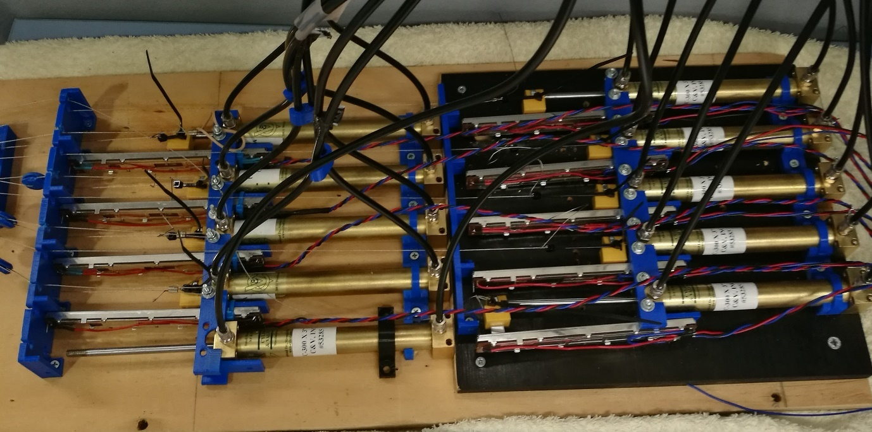

Figure 10 Prototyped cylinder array

Linear sliding potentiometers were used as position sensors for each individual cylinder. These were mounted directly to each cylinder via a two-component structure, in order to minimise space requirements as depicted in Figure 11. This was then scaled up to the structure seen in Figure 10.

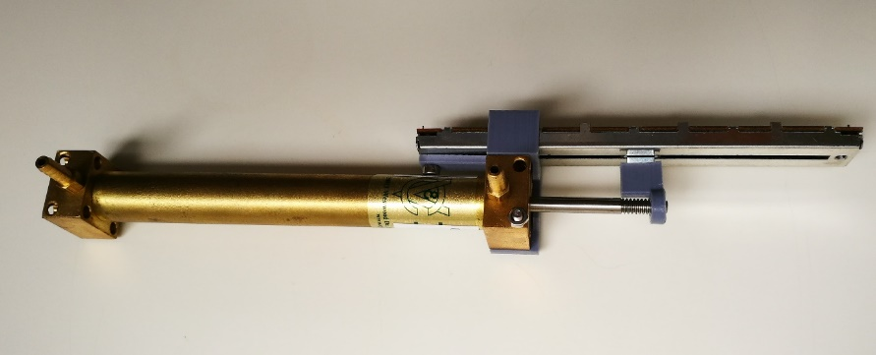

Figure 11 Cylinder with potentiometer mount and potentiometer attached

The two-component mounting structure was designed to facilitate ease of connecting the cables to the hand. All brackets to hold the cylinders and position sensors, as well as the cable guides at the end of each position sensor were designed and 3D printed using the same settings and material as the hand itself.

#### Control

To better demonstrate the functionality of the prosthetic, typical non-invasive control strategies such as electro-myography (EMG) were passed up for a more reliable, comprehensive and simpler schema – motion capture. To do this, a Leap Motion controller (LEAP, 2018) was employed. The Leap motion controller uses stereo infrared cameras set to virtualise a human hand, and in doing so can detect the relative location, angles and sizes of all the joints and bones in the hand. Utilising Leap’s application programming interface (API), these angles can be obtained and fed into the control system for the hand allowing mimicking.

Although this control system is not ideal for a person requiring a prosthesis, it is a useful as a control strategy to demonstrate the range of gestures and motions that the prototype can achieve. It allows complex gestures to be quickly mapped to the appropriate cylinder positions and saves a considerable amount of time that would otherwise be spent developing control algorithms with emerging technologies, i.e. EMG.

#### Software

Github was used for version control and as a development tool throughout the duration of the project. All digital project elements were uploaded to GitHub[1], allowing change tracking, roll backs, and cloud-based collaboration.

The project has been programmed in C, and run through Visual Studio on Windows 10. The individual programmable systems on a chip (PSoC) have been programmed through PSoC Creator, which utilises both a general user interface (GUI) as well as C.

Leap Motion

Leap Motion

CPU

CPU

PSoC

PSoC

Figure 12 Microcontroller communications flowchart

The structure of the software is shown in Figure 12. A program on the computer accesses the Leap Motion device API to detect the current angles of the joints of a user’s fingers. The program converts the angles into the required values for the position sensors, which are then communicated to the two PSoC devices through the UART serial communications protocol. 3 threads are used to distribute computational load: a main thread that receives the angles from the Leap Motion controller and pushes those values to two sub-threads, which communicate directly with the PSoCs. This type of structure allows rapid scaling for the system should more actuators wish to be used.

The PSoCs support 4 pulse-width-modulated (PWM) signals, which allows control of 4 cylinders. Each PSoC receive inputs from the 4 sliding potentiometers and digitises them through successive-approximation (SAR) analogue-to-digital (ADC) converter. They then run the readings through a 2.5kHz 7-value median filter to smooth the input and reduce noise. Interrupts allow asynchronous communications with the connected computer, to both send and receive positional data. This information is then used to runs 4 separate proportional-integral-derivative (PID) controllers at 100Hz, whose output is fed directly into the servo motors controlling the proportional valves.

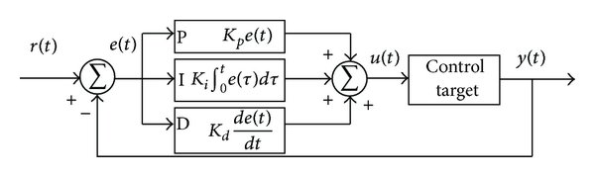

Figure 13 Classical PID controller

#### Controller Tuning Process

In order to demonstrate the precision of hydraulic actuation, correctly tuning the PID controller was essential. To facilitate this process, software was developed to return the actual and desired positions of the cylinders from the microcontroller controlling the cylinders. Further code was developed to graph historical data to analyse the response of the system. This however was a slow process and thus python was eventually used to graph the individual cylinder responses in real-time, enabling a faster tuning process.

A significant characteristic of the system that influenced tuning was the dead space in the hydraulic valves. It was discovered that 15° either side of the centre position of the valves would still leave the valve closed. To combat this, offsets needed to be introduced to indicate the position at which fluid would begin to flow. This introduced a delay into the response, as the servos controlling the valves would have to cross the complete 30° of dead-zone in order to change the direction of the cylinder.

The Ziegler-Nichols method was initially implemented to roughly determine PID values prior to further fine tuning. Due to the complex dynamics of the system and the nature of some of the components, it was discovered that the integral term would cause significant instability if the servo motor offsets were not perfect. This proved to be problematic, as the movements were not overly consistent due to the hobby grade quality of the servo motors. This resulted in the integral term being kept lower than the Ziegler Nichols method would recommend which led to slow steady-state correction.

### Model Development

#### Force Estimation

##### Assumptions

A few key assumptions are made in this analysis to simplify a complex model. The first assumption is that the force from the cable controlling the distal and middle phalanx is transmitted as a torque around the axis of the proximal interphalangeal (PIP) joint. The second is the orientation of the fingers and dynamometer when the grip force is being measured, this being demonstrated in Figure 15 on the left with the dynamometer in the middle of the middle phalanx.

The final assumption is a dual rigid body addition simplification. This assumes the total force on the dynamometer can be calculated based on an addition of the force at that point from two torques assuming the opposite joint is rigid as shown in Figure 14. This assumption can be made because the hand is locked and all joints unmoving when force is being applied to the dynamometer. Additionally, when operating the PIP and distal interphalangeal (DIP) joints are treated as independent to the MCP joint. This means we can assume any loads caused by the cable running through the proximal phalanx part are balanced and thus the two forces do not affect each other.

This assumption may oversimplify the model and cause inaccuracies, however without a comprehensive simulation analysis all the intricacies of the model are difficult to account for. The path of the tension cable through the hand means the torque force could be applied variably throughout the finger and could shift as force increases. For these reasons the simplified model is being tested.

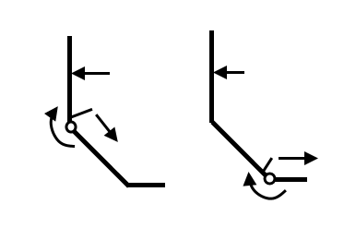

Figure 14 Rigid Body Assumption

##### Finger Model Analysis

The model for the theoretical dynamometer force is developed with the middle phalanx vertical and proximal phalanx at 45 degrees as depicted on the left of Figure 15. This means both MCP and PIP joint internal angles are at 135 degrees. The overall force is derived from the two torques generated at the two joints, T1 and T2. These torques are converted into linear forces with the knowledge of the perpendicular distance to the point the dynamometer will be resisting depicted in Equation 1. The dynamometer resistance point is assumed to be horizontal across all fingers. The values in Equation 1 represent the measurements and forces on the right of Figure 15.

|  |
| --- |
|  |

Figure 15 Finger orientation for analysis (left) and variable names for analysis (right)

$$F_{dynamometer}=\frac{T_{1}}{R_{1}}+\frac{T_{2}}{R_{2}}=\frac{F_{1}r_{1}}{R_{1}}+\frac{F_{2}r_{2}}{R_{2}}$$

Equation 1

The first step is to calculate the tension along the cables in order to calculate any friction losses and torques generated by the cables. For this analysis the coefficient of friction for the parts printed in PLA is taken to be 0.492 (Pawlak, 2018).

$$F_{c}=Pressure×\left(Cyl Bore Area-Rod Area\right)$$

Equation 2 Cylinder Force Formula

To calculate F1 from equation 1 the two frictional losses from the wire guides at the end of the potentiometers and at the wrist of the hand must be taken into account. For F1 the force is doubled after it has gone through the wire guides at the end of the potentiometers due to the pulley.

$$F_{1}=\left(2\left(F_{c}-N_{1}μ\right)\right)-N_{2}μ$$

The normal force can be calculated using the angle the cable bends. At the mid-angle the normal force will be maximum resulting in a normal represented by the equation below where $θ_{g1}$ is the angle depicted in Figure 18 for the lower cylinder with an attached pully.

$$N_{1}=F_{c}\cos\left(\frac{180-θ_{g1}}{2}\right)$$

The second normal force is calculated in a similar method but uses the tension force already reduced by the friction from N1.

Calculating F2 uses the same method but has no pulley so N3 and N4 use the same formula as N1. Equation 3 is the cylinder force less the friction losses from N3 and N4.

Equation 3

$$N_{3}=F_{c}\cos\left(\frac{180-θ_{g2}}{2}\right)$$

$$N_{4}=F_{c}\cos\left(\frac{180-θ_{h2}}{2}\right)$$

These formulas can be used to generate the force each finger should contribute to force measurement registered on the dynamometer for the specific pressure and dynamics of the hand.

Given the values in Table 5, the results of this model for each finger is revealed in Figure 16 and the total force the dynamometer theoretically should register for different pressures is depicted in Figure 17. The values for the angles and *R* and *r* values are determined from the hand CAD model and can be found in Appendix B.

Table 5 Single Analysis variable values

|  |  |
| --- | --- |
| **Variable** | **Value** |
| µ - coefficient of friction | 0.492 |
| P – pressure (Pa) | 18000 |
| Cylinder bore area (m2) | 7.0968e-05 |
| Cylinder rod area (m2) | 1.8064e-05 |

Figure 16 Theoretical individual finger force contribution to dynamometer grip test

Figure 16 reveals the force contribution to be similar for each finger with the middle finger contributing the 20% more force than the mean of 65N and little finger the 20% less than the mean. Figure 17 shows the results scale linearly with a change in the pressure in the hydraulic system. This figure has also been converted into kilograms of force for a more direction comparison between the theoretical results and the experimental below.

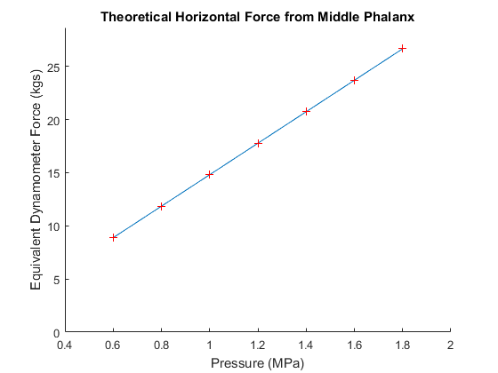

Figure 17 Theoretical dynamometer grip force with change in pressure

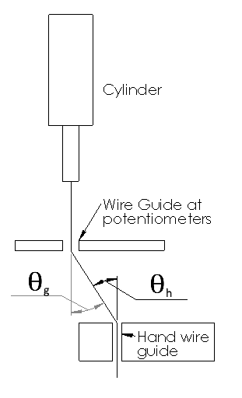

Figure 18 Cable angle locations for friction loss

#### Finger Angle to Cylinder Position Mapping

As part of the model for controlling the position of the fingers on the hand, a formula for converting between the linear motion of the cylinders and the rotation at each joint was developed. These formulas were developed experimentally by moving the cylinder to incremental linear positions and measuring the angle of each joint using a protractor. This data was plotted and found to fit a linear equation with an R2 value of 0.9936 as depicted in Figure 19.

Figure 19 Experimental linear to finger angle data for the cylinder controlling the little fingers MCP joint

Using this relationship, a formula for each finger was found. However, the movement of the MCP joint affects the length required of the PIP and DIP joints. To solve this the same method was used to measure the PIP joint when the MCP joint was at its maximum and minimum (finger straight up or flat). Two linear formulas were developed from this data which was then linearly interpolated as the MCP joint was lowered resulting in a formula taking the shape of a plane in Figure 21. Using these developed formulas yielded close enough mapping so that when using the Leap motion controller visually the 3D printed hand would copy the position of the hand being tracked. Figures showing the formula used for the other three fingers can be found in Appendix A.

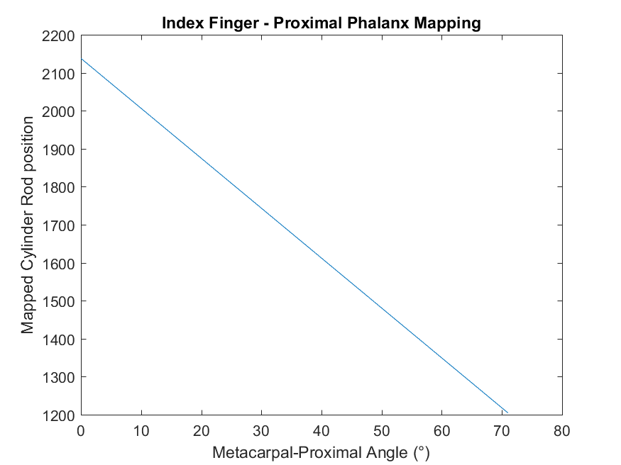

Figure 20 Linear position to MCP joint angle conversion formula for index finger

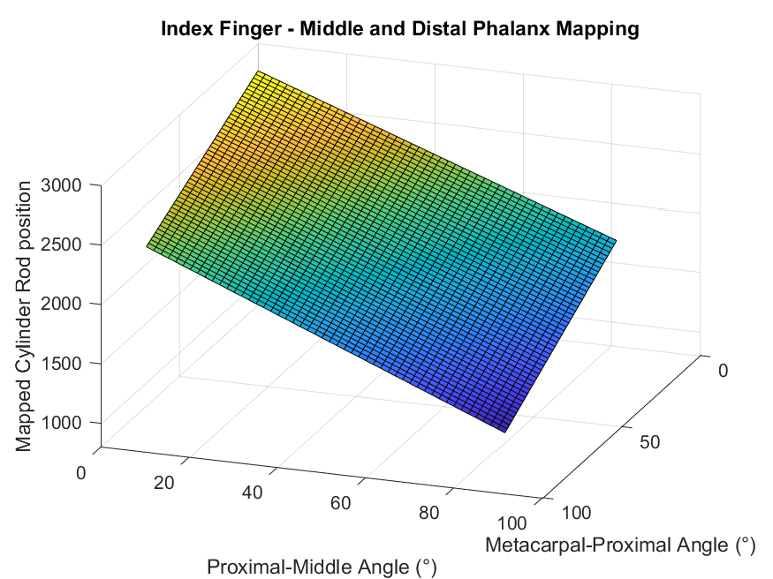

Figure 21 Linear position to PIP joint angle conversion formula for index finger

### Functional evaluation

#### Precision

The precision of the hand is evaluated using the data feedback from the PSoC devices when running the system. Figure 22 to Figure 26 represent the response of individual cylinders to a desired position over time. The top half of the figures represent the absolute error between desired potentiometer position and the potentiometer position reported by the analog-digital converter (ADC). The projects design requirements specified the goal for error of the hydraulic cylinder position control system to be within ±1° of the angular position. To evaluate how well the system performed this angular is converted into a linear error using an average of how far 1° maps to the potentiometers values. The process used the formulas for all cylinders and the results are shown in Table 6. This averaging results in an error of ±13.32.

Table 6 Linear error corresponding to 1°

|  |  |
| --- | --- |
| **Formulas** | **Pot. Diff over 1°** |
| y = -763.63x + 2768.9 | -13.3279 |
| y = -860.17x + 2137.9 | -15.0128 |
| y = -703.44x + 2065.4 | -12.2773 |
| y = -752.06x + 2707.1 | -13.1259 |
| y = -705.92x + 2182.4 | -12.3206 |
| y = -790.62x + 2852.7 | -13.7989 |
| y = -750.32x + 2845 | -13.0956 |
| y = -753.43x + 2173.6 | -13.1498 |
| y = -754.84x + 2152.7 | -13.1744 |
| y = -742.33x + 2064.5 | -12.9561 |
| y = -753.25x + 2051.8 | -13.1467 |
| y = -829.18x + 2207.3 | -14.4719 |
| **Average** | -13.3215 |

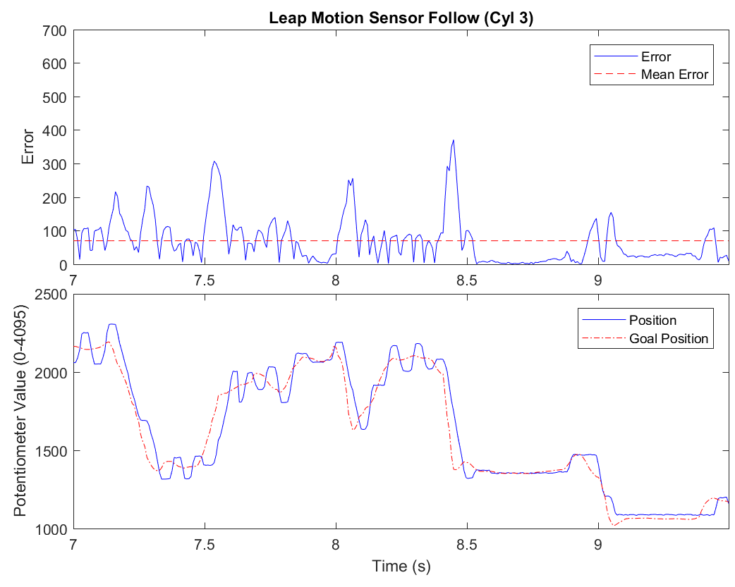

Figure 22 Error and System Response of Cylinder 3 following leap motion controller

Figure 22 represents the response of a single cylinder when the entire hand is following the leap motion controller mimicking a user’s hand opening, closing and performing different gestures. The mean error is 69.18 which is well about the desired error of 13.32. However, the graph shows the cylinder is follow the input goal position and the largest error spikes occur when the goal position undergoes a rapid change, a motion like quickly forming a fist would cause this. Under that condition the cylinder is limited by the current flow rate in the system and how much the other 7 cylinders are moving. It is believed the error is reasonable given the rate of change of the goal position.

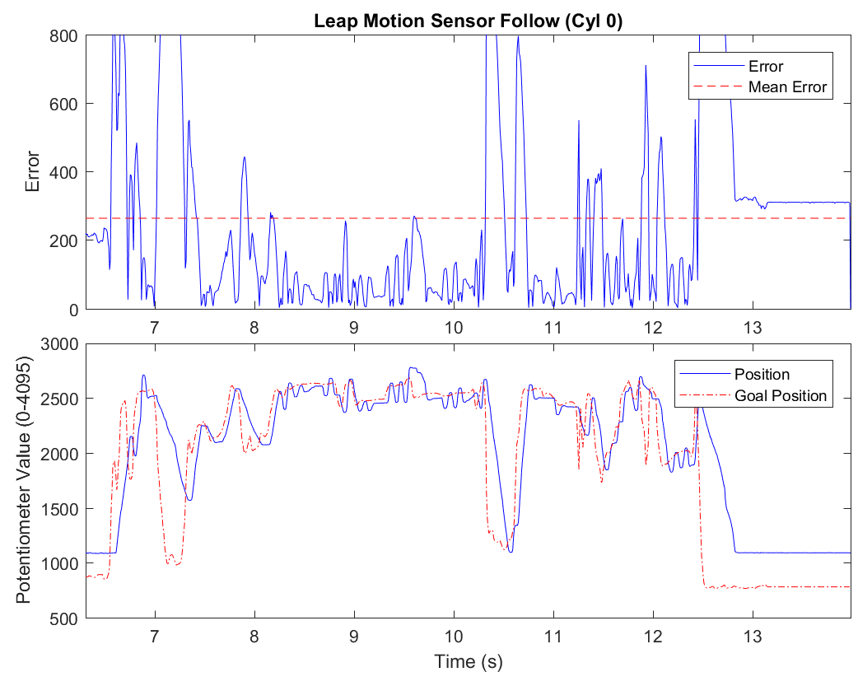

Figure 23 Error and System Response of Cylinder 0 following leap motion controller

Figure 23 is another example of a cylinder’s response to following the leap motion controller. The average error is 263.52, significantly larger than the desired maximum error. The cylinder this graph represents controls the angular motion of the PIP and DIP joints. The mapping formula for these cylinders have a much larger range of roughly 1700 instead of 1200 for the cylinders controlling the MCP joint angular motion. From this figure it can be observed that the speed of the cylinder is the limiting factor in reducing the error when the input is a hand in motion.

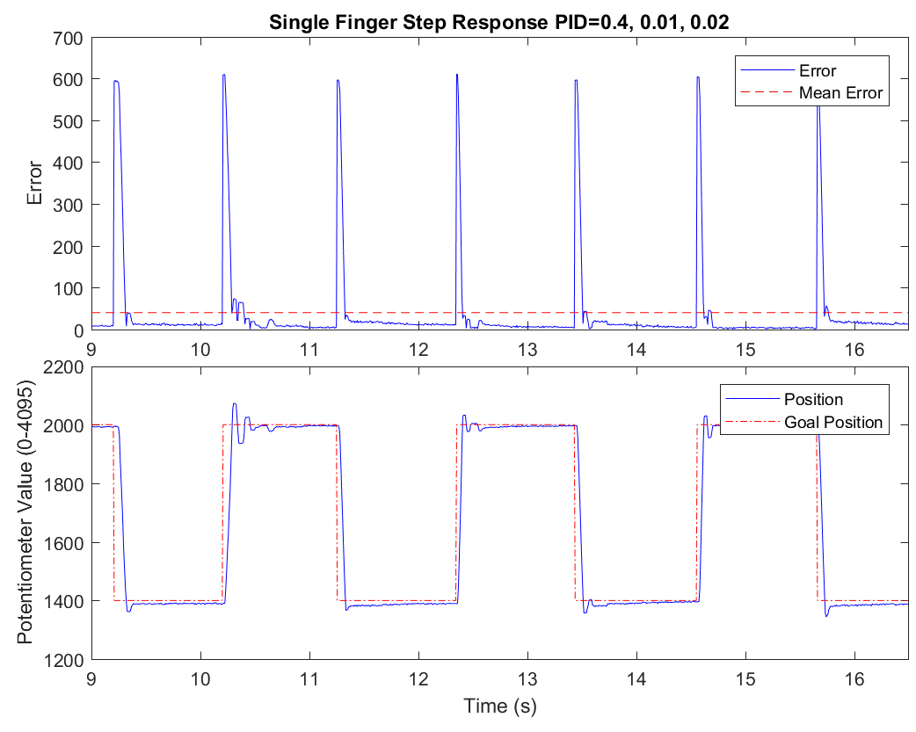

Figure 24 Error and System Response of a single cylinder follow with a large step input

Figure 24 represents the response of a single cylinder to a large step input when only that cylinder is moving. The average error is 39.47, however this is largely due to the initial step change. It can be observed that given a steady input the system quickly settles to a stable low error with the error toward the end of the step being below 10. This satisfies our desired error of less than 13.32 and shows that given enough time the hand can be achieve precision of <1°.

This result is under optimal condition with no other cylinders running altering the maximum available flow rate from the pump or fluctuating the pressure in the system.

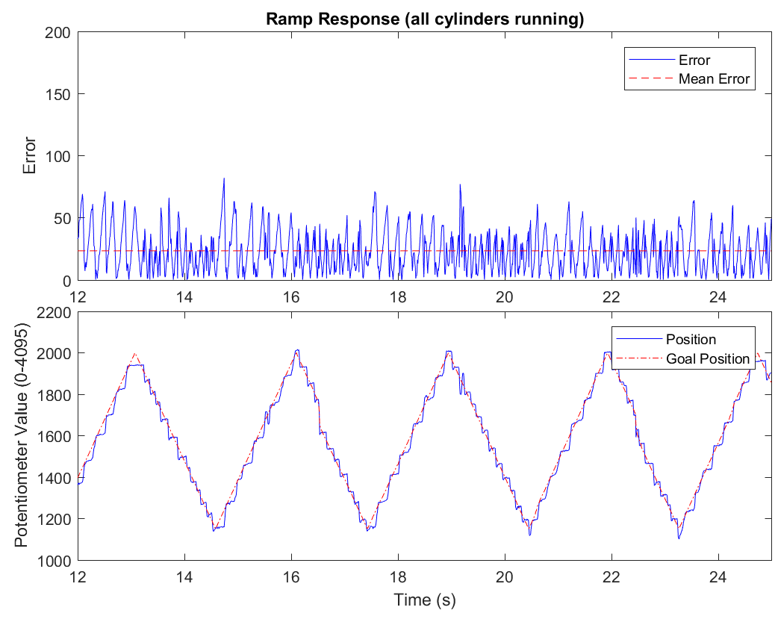

Figure 25 Error and System Response of a cylinder follow with a ramp input with all cylinders moving

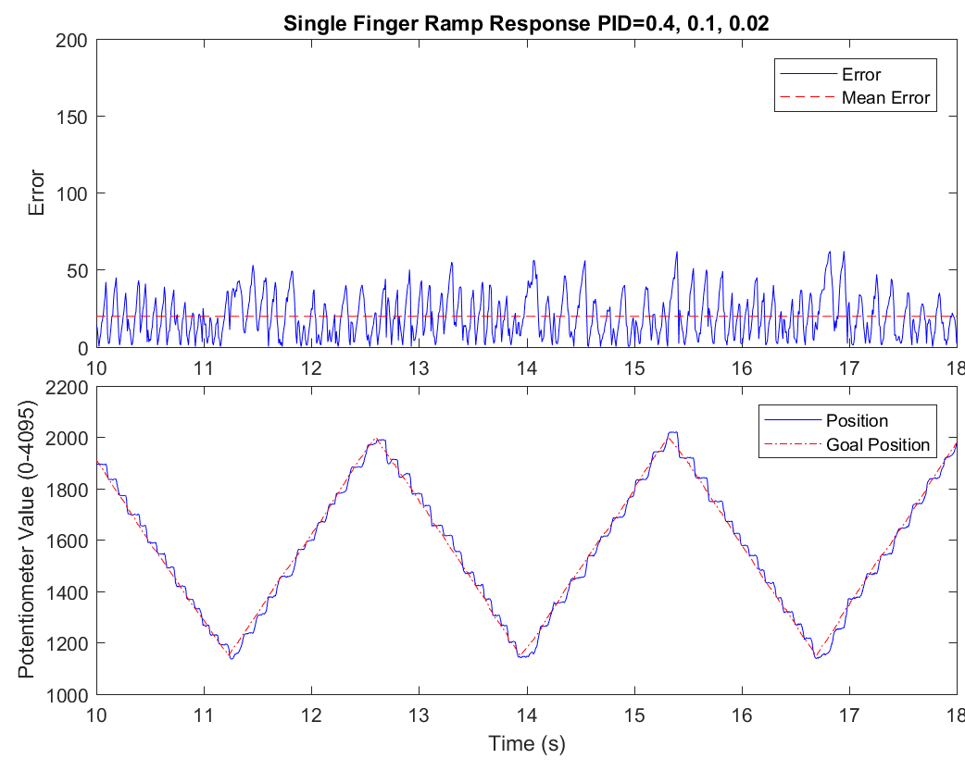

Figure 26 Error and System Response of a single cylinder follow with a ramp input

Figure 25 and Figure 26 demonstrate the change in error when all cylinders are running compared to a single cylinder. With the same ramp input, PID values and offset values for the servo motors the average error increases from 19.71 to 23.28 with the maximum errors changing from 62 to 82, a 32% increase. This error increase would be larger if the ramp input had a larger slope requiring more flow from the pump. This is a limitation of the current system and control set up.

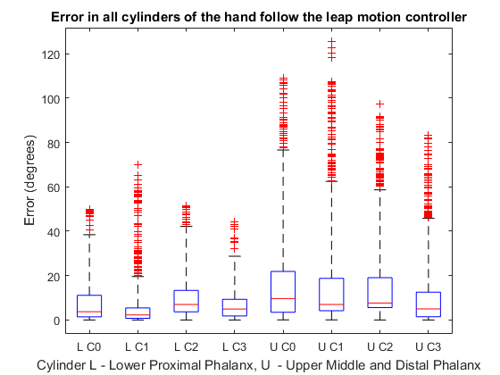

Figure 27 Error in degrees for all cylinders following the Leap motion controller input

Figure 27 is a box and whisker plot representing the error spread of all cylinders when following the leap motion controller as a system input. The error values in this plot have been converted to the angular error in degrees. From the plot it is apparent all median degree errors for the lower 4 cylinders are less than the upper 4 cylinders which reflects the observations from the leap following error graphs above where the upper cylinders have larger error due to a larger operational range. The median angular errors for the lower 4 cylinders are 3.7, 2.27, 7.0, and 5.0 while the upper 4 cylinders are 9.7, 7.0, 7.6, and 5.0. Compared to the desired maximum angular error of 1 degree these are very high but not unreasonable for a system with a constant input change.

Overall, the system only meets the precision requires set out in the design requirements of this project when the system has a steady input for at least 1 full second. When in motion the systems error fluctuates a lot, with an average error higher than the desired 13.3. The appears to be a limitation of the flow rate of the system and would improve if the maximum flow rate for each cylinder were increased or the input values were smoothed to a maximum rate of change.

The fluctuating error is also likely a product of the proportional control mechanism used to control the flow into the cylinders. It relies on servo motors, and as mentioned above, has a large 30° dead zone between switching direction. This causes a noticeable delay between cylinder direction changes and makes the system prone to overcorrecting.

#### Grip force

Figure 28 Theoretical and Experimental Cylinder Retraction Force

Figure 28 presents the experimental results of the force obtained from a single cylinder under different pressures from the hydraulic pump. To measure the output force a force gauge braced against the end of our base board was attached by a cable to a cylinder on our baseboard. The experiment measured the retraction force of the cylinder with the same hose setup as when the hand is in operation. This means the hydraulic fluid travels into a proportional valve then to the cylinder. The graph compares this to the theoretical force obtained using Equation 2 and the specifications for the cylinders we acquired. The graph shows the actual force is about 75% lower than the theoretical force for a given pressure, represented by the efficiency line in dotted red. This experimental result shows there are losses in the system that have not been taken account of.

Figure 29 Theoretical and Experimental Dynamometer power grasp measurement

Figure 29 shows three series of data for the power grasp that we measured from a dynamometer power grasp measuring device and from the theoretical model about. The experimental results (blue) show a linear relationship with pressure which indicates if the maximum force of the hand needs to be increased it could be done by increasing the pressure. This would also require the grade of components in the system to be upgraded to handle higher pressures, as 1.8MPa is the current operational maximum, limited by the proportional valves at 1.8MPa. The purely theoretical model of dynamometer strength (orange) is roughly 250% the experimental result. While when the experimental force from the cylinders from Figure 28 is inserted into the theoretical model the result is about 185% of the experimental results.

All three series appear to be linear from the range of pressures tested. Due to this, to correct the model, an error factor could be added to the model to account for unmodelled losses and improve the accuracy of the model. Although developing an idea of what increases the error factor would require further research.

The design requirements of the project called for 20kg of force in a power grasp. The hand achieved a maximum of 10.5kg at 1.8MPa pressure. Extrapolating from the graph a pressure of 3.57 MPa would be required to achieve 20kg on the dynamometer.

A few concerns during the experiment were raised. Firstly, it was unclear if all the force was being transmitted into the dynamometer as the tensioning component in the cables (zip ties) could have been deforming, representing a loss in the potential force. To remedy this an alternative more robust method of tension the tendon cables would need to be developed. Further experimentation at higher pressures was not possible due to the tensioning components breaking at higher forces. Given more time, a stronger component would be used there and the full design power grasp force may be achieved.

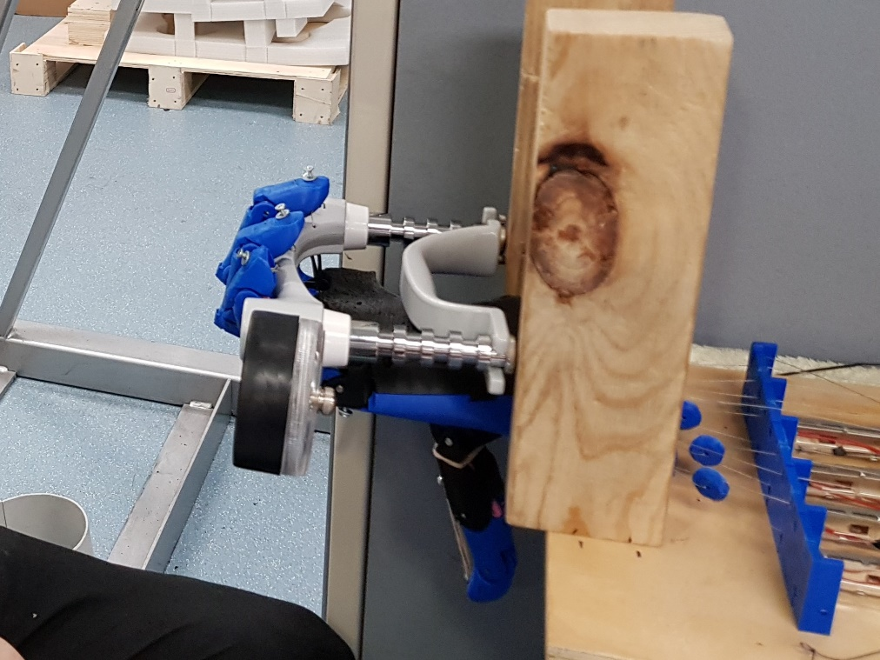

Figure 30 Dynamometer Power Grasp Experiment Setup

#### DoF and Range of Motion

A focus for the project is achieving as many degrees of freedom in the hand as possible. The hydraulic hand currently has 8. The MCP joint of each finger is a 4 DoF’s, while the upper half PIP and DIP joints are linked introducing another 4 DoF’s. Table 7 represents a range of gestures the hydraulic hand can perform. These gestures were recorded off a real hand using the Leap motion controller, then programmed in as pre-set gestures. The gestures demonstrate how each finger is independent from each other and how the distal and middle phalanges are independent from proximal phalanx.

Table 7 Figures of gestures using the hydraulic hand

|  |  |
| --- | --- |
|  |  |
|  |  |
|  |  |
|  |  |
|  |  |
|  |  |
|  |  |
|  |  |
|  |  |
|  |  |
|  |  |

Grip speed was another design requirement of the project. This represents the time it takes for a hand to transition from fully open to a fist. The requirement is to achieve 170°/s per joint, which for our range of motion of about 0° to 80° for each joint is open hand to fist in 0.47 seconds. Over 5 trials at closing the hand we achieved a fastest time of 1.3 seconds but the mean time was 1.69 seconds. These 5 occasions can be seen on the projects GitHub[2] page in the “Grip Videos” folder. Table 8 represents the individual durations for each fit forming trial.

Table 8 Fist Forming Times

|  |  |
| --- | --- |
| **Video File** | **Duration(s)** |
| Grip Test 1.mp4 | 1.82 |
| Grip Test 2.mp4 | 1.652 |
| Grip Test 3.mp4 | 1.514 |
| Grip Test 4.mp4 | 1.299 |
| Grip Test 5.mp4 | 2.158 |
| Mean | 1.6886 |

### Discussion

The motivation for this project is to provide the reader with the vision of the development of a prosthetic hand that rivals the human hand in terms of precision and strength. Current literature suggests that fluid power has one of the greatest potentials to allow amputees regain their standard of living.

A hydraulic actuated prosthetic hand was developed and tested which showed promising results for the actuation technology. Whilst the design requirements were not met, it was found that they were readily achievable given further development.

At a low pressure of 18 bar, forces higher than that of majority of currently available prosthetic solutions were demonstrated, despite numerous inefficiencies and lack of optimisation. Precision control was obtained at a degree better than alternative fluid powers such as pneumatics, allowing gradual and controlled movements with variable speed. However, precision performance was not better than electrical solutions due to limitations in control hardware.

The successes found from this project demonstrate the capacity for an extremely promising prosthetic device with further development.

#### Suggestions for improvements

Throughout the course of this project severe limitations were discovered with the design of the prototype. Should these be mitigated and worked upon, hydraulic powered prosthetics have the potential to revolutionise current amputees’ quality of life. These include:

* Higher quality proportional valves, such as proportional solenoid valves, to combat hydraulic valve offsets and servo motor inaccuracies.
* Higher quality cylinder position sensors to more accurately determine cylinder extension and reduce noise.
* Reverse the cylinders such that the rods are oriented proximally, rather than distally. This allows a greater acting area for hydraulic fluid, increasing output force considerably.
* Employ Bowden cables or Teflon liner in order to reduce the friction seen between wires and the structure of the prosthetic. This caused significant wear on the wires which in some cases caused them to snap.
* Polish joints or use alternative materials for moving parts as considerable friction caused unexpected movements.
* Use alternative tensioning methods to tension the wires to the actuators, as when testing under load, the cable ties were snapping.
* Consider using a radiator as oil temperatures increased during operation, lowering viscosity of the oil used considerably. This could cause excessive wear after extended periods of use.

### Acknowledgement

This work was supported significantly by Hydac, Valvoline, and Cylval. The project would not have been possible without their assistance. We would like to extend a special thank you to Mark Keen and Guy Howick from Hydac, Anthony McDermott from Valvoline, and Sally Jessop from Eastern Hand Rehab for their generosity. We would like to further acknowledge Chao Chen from Monash University and researchers of the Laboratory for Motion Generation and Analysis for their support and guidance throughout the duration of the project.

### References

Abayasiri, R. A. M., Madusanka, D. G. K., Arachchige, N. M. P., Silva, A. T. S., & Gopura, R. A. R. C. (2017, 17-20 July 2017). *MoBio: A 5 DOF trans-humeral robotic prosthesis.* Paper presented at the 2017 International Conference on Rehabilitation Robotics (ICORR).

Ayub, R., Villarreal, D., Gregg, R. D., & Gao, F. (2017). Evaluation of transradial body-powered prostheses using a robotic simulator. *Prosthetics and orthotics international, 41*(2), 194-200. doi:10.1177/0309364616650077

Baril, M., Laliberté, T., Guay, F. o., & Gosselin, C. m. (2010). Static Analysis of Single-Input/Multiple-Output Tendon-Driven Underactuated Mechanisms for Robotic Hands. (44106), 155-164. doi:10.1115/DETC2010-28933

Durfee, W., Xia, J., & Hsiao-Wecksler, E. (2011, June 29 2011-July 1 2011). *Tiny hydraulics for powered orthotics.* Paper presented at the 2011 IEEE International Conference on Rehabilitation Robotics.

El-Hamad, H. J., Ahmad, S. A. B., & Ishak, A. J. B. D. (2017). Modelling of High Output Force Dielectric Elastomer Actuator. *International Journal of Mechanical Engineering and Robotics Research, 6*(2), 100-103. doi:10.18178/ijmerr.6.2.100-103

Foglyano, K. M., Kobetic, R., To, C. S., Bulea, T. C., Schnellenberger, J. R., Audu, M. L., . . . Triolo, R. J. (2015). Feasibility of a Hydraulic Power Assist System for Use in Hybrid Neuroprostheses. *Applied Bionics and Biomechanics, 2015*, 205104. doi:10.1155/2015/205104

Gailey, A. S., Godfrey, S. B., Breighner, R. E., Andrews, K. L., Zhao, K. D., Bicchi, A., & Santello, M. (2017). Grasp Performance of a Soft Synergy-Based Prosthetic Hand: A Pilot Study. *IEEE Transactions on Neural Systems and Rehabilitation Engineering, 25*(12), 2407-2417. doi:10.1109/TNSRE.2017.2737539

Grioli, G., Catalano, M., Silvestro, E., Tono, S., & Bicchi, A. (2012, 7-12 Oct. 2012). *Adaptive synergies: An approach to the design of under-actuated robotic hands.* Paper presented at the 2012 IEEE/RSJ International Conference on Intelligent Robots and Systems.

Hashim, N. A., Abd Razak, N. A., Abu Osman, N. A., & Gholizadeh, H. (2018). Improvement on upper limb body-powered prostheses (1921–2016): A systematic review. *Proceedings of the Institution of Mechanical Engineers, Part H: Journal of Engineering in Medicine, 232*(1), 3-11. doi:10.1177/0954411917744585

Hichert, M., Abbink, D. A., Kyberd, P. J., & Plettenburg, D. H. (2017). High Cable Forces Deteriorate Pinch Force Control in Voluntary-Closing Body-Powered Prostheses. *PLoS ONE, 12*, e0169996.

Hichert, M., Vardy, A. N., & Plettenburg, D. (2018). Fatigue-free operation of most body-powered prostheses not feasible for majority of users with trans-radial deficiency. *Prosthetics and orthotics international, 42*(1), 84-92. doi:10.1177/0309364617708651

Leal-Naranjo, J. A., Ceccarelli, M., & Torres-San Miguel, C. R. (2017). *Mechanical Design of a Prosthetic Human Arm and its Dynamic Simulation*, Cham.

LEAP. (2018). Home - Leap Motion. Retrieved from <https://www.leapmotion.com/>

Liu, Y., Yang, D., Jiang, L., & Liu, H. (2015, 7-11 July 2015). *A synthetic framework for evaluating the anthropomorphic characteristics of prosthetic hands.* Paper presented at the 2015 IEEE International Conference on Advanced Intelligent Mechatronics (AIM).

Love, L. J., Lind, R. F., & Jansen, J. F. (2009, 10-15 Oct. 2009). *Mesofluidic actuation for articulated finger and hand prosthetics.* Paper presented at the 2009 IEEE/RSJ International Conference on Intelligent Robots and Systems.

Massy-Westropp, N. M., Gill, T. K., Taylor, A. W., Bohannon, R. W., & Hill, C. L. (2011). Hand Grip Strength: age and gender stratified normative data in a population-based study. *BMC Research Notes, 4*, 127.

Mata Amritanandamayi, D., Udupa, G., & Sreedharan, P. (2018). A novel underactuated multi-fingered soft robotic hand for prosthetic application. *Robotics and Autonomous Systems, 100*, 267-277. doi:<https://doi.org/10.1016/j.robot.2017.11.005>

Millstein, S., Bain, D., & Hunter, G. A. (1985). A review of employment patterns of industrial amputees—factors influencing rehabilitation. *Prosthetics and orthotics international, 9*(2), 69-78. doi:10.3109/03093648509164708

Morales, G. (2018). Anthropomorphic Robot Hand and Arm CAD Model.

Mottard, A., Laliberté, T., & Gosselin, C. (2017). *Underactuated tendon-driven robotic/prosthetic hands: Design issues.* Paper presented at the Robotics: Science and Systems.

Nath, J. D., & Durfee, W. K. (2017). Optimization and Design Principles of a Minimal-Weight, Wearable Hydraulic Power Supply. (58271), V001T030A002. doi:10.1115/DSCC2017-5046

Organ, J. M. (2008). Thieme atlas of anatomy: General anatomy and musculoskeletal system thieme atlas of anatomy: neck and internal organs. *JAMA, 299*(2), 220-226. doi:10.1001/jama.2007.36-a

Ottobock. (2018). Body-powered prosthetic solutions. Retrieved from <https://www.ottobockus.com/prosthetics/upper-limb-prosthetics/solution-overview/body-powered-prosthetic-solutions/>

Pai, U. J., Sarath, N. P., Sidharth, R., Kumar, A. P., Pramod, S., & Udupa, G. (2016, 18-20 Dec. 2016). *Design and manufacture of 3D printec myoelectric multi-fingered hand for prosthetic application.* Paper presented at the 2016 International Conference on Robotics and Automation for Humanitarian Applications (RAHA).

Pawlak, W. (2018). *Wear and Coefficient of Friction of PLA-Graphite Composite in 3D Printing Technology*. Paper presented at the Engineering Mechanics International Conference, Svratka, Czech Republic. Conference Paper retrieved from

Perry, B. N., Moran, C. W., Armiger, R. S., Pasquina, P. F., Vandersea, J. W., & Tsao, J. W. (2018). Initial Clinical Evaluation of the Modular Prosthetic Limb. *Frontiers in Neurology*.

Piazza, C., Catalano, M. G., Godfrey, S. B., Rossi, M., Grioli, G., Bianchi, M., . . . Bicchi, A. (2017). The SoftHand Pro-H: A Hybrid Body-Controlled, Electrically Powered Hand Prosthesis for Daily Living and Working. *IEEE Robotics and Automation Magazine, 24*(4), 87-101. doi:10.1109/MRA.2017.2751662

Proaño-Guevara, D., Procel-Feijóo, J., Zhingre-Balcazar, J., & Serpa-Andrade, L. (2018). *Biomimetical Arm Prosthesis: A New Proposal*, Cham.

Resnik, L., & Klinger, S. (2017). Attrition and retention in upper limb prosthetics research: experience of the VA home study of the DEKA arm. *Disability and Rehabilitation: Assistive Technology, 12*(8), 816-821. doi:10.1080/17483107.2016.1269212

Rice, M. S., Leonard, C., & Carter, M. (1998). Grip Strengths and Required Forces in Accessing Everyday Containers in a Normal Population. *American Journal of Occupational Therapy, 52*(8), 621-626. doi:10.5014/ajot.52.8.621

Riet, D. v. d., Stopforth, R., Bright, G., & Diegel, O. (2013, 9-12 Sept. 2013). *An overview and comparison of upper limb prosthetics.* Paper presented at the 2013 Africon.

Sanchez, J. (2018). Revolutionizing Prosthetics. Retrieved from <https://www.darpa.mil/program/revolutionizing-prosthetics>

Schweitzer, W., Thali, M. J., & Egger, D. (2018). Case-study of a user-driven prosthetic arm design: bionic hand versus customized body-powered technology in a highly demanding work environment. *Journal of NeuroEngineering and Rehabilitation, 15*(1), 1. doi:10.1186/s12984-017-0340-0

Semasinghe, C. L., Ranaweera, R. K. P. S., Prasanna, J. L. B., Kandamby, H. M., Madusanka, D. G. K., & Gopura, R. A. R. C. (2018). HyPro: A Multi-DoF Hybrid-Powered Transradial Robotic Prosthesis. *Journal of Robotics, 2018*. doi:10.1155/2018/8491073

Touch Bionics Product Catalogue. (2015). In (pp. 4). Massachusetts: Touch Bionics.

Waters, R. L., & Mulroy, S. (1999). The energy expenditure of normal and pathologic gait. *Gait & Posture, 9*(3), 207-231. doi:<https://doi.org/10.1016/S0966-6362(99)00009-0>

Yokokohji, Y., Muramori, N., Sato, Y., & Yoshikawa, T. (2005). Designing an encountered-type haptic display for multiple fingertip contacts based on the observation of human grasping behaviors. *The International Journal of Robotics Research, 24*, 717+.

### Appendices

#### Appendix A – Finger Mapping Plots



Figure 31 Linear position to MCP joint angle conversion formula for index finger



Figure 32 Linear position to PIP joint angle conversion formula for index finger

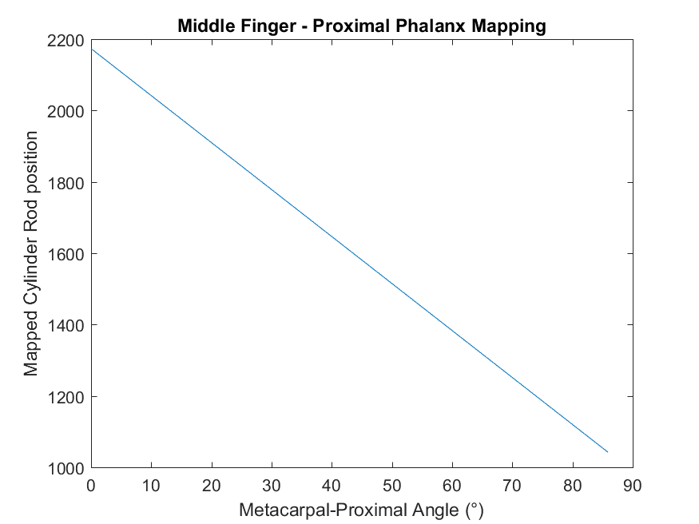

Figure 33 Linear position to MCP joint angle conversion formula for index finger

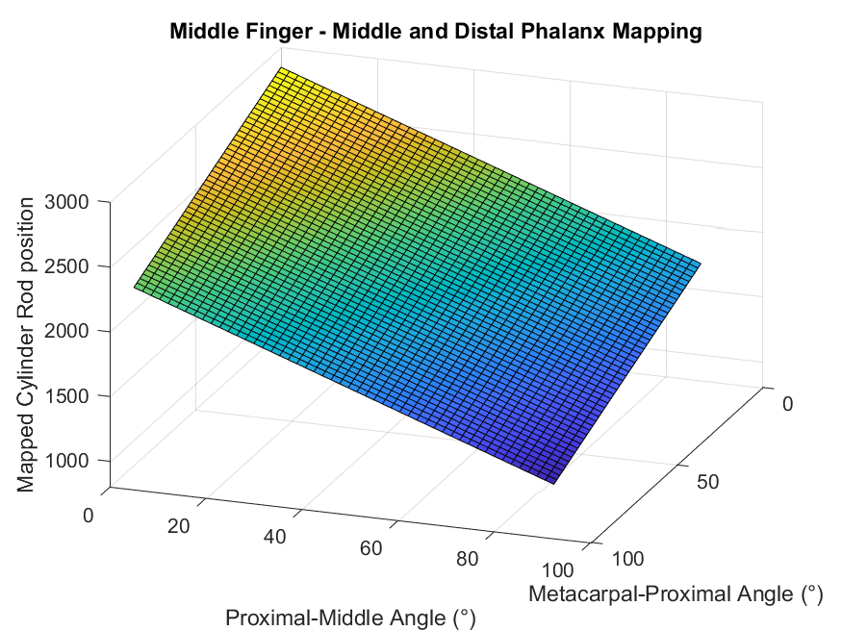

Figure 34 Linear position to PIP joint angle conversion formula for middle finger

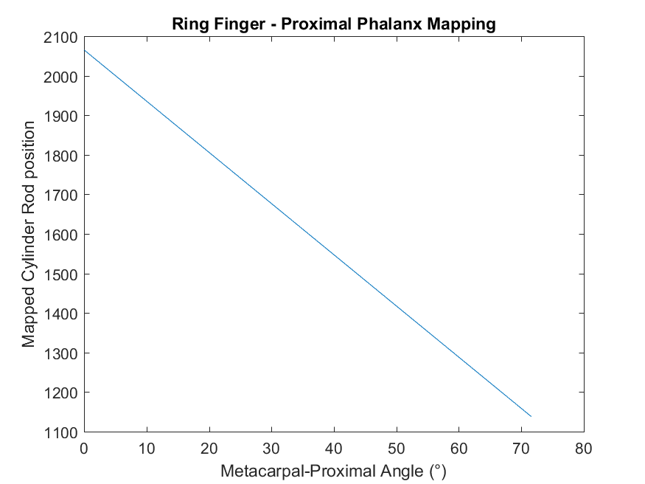

Figure 35 Linear position to MCP joint angle conversion formula for index finger

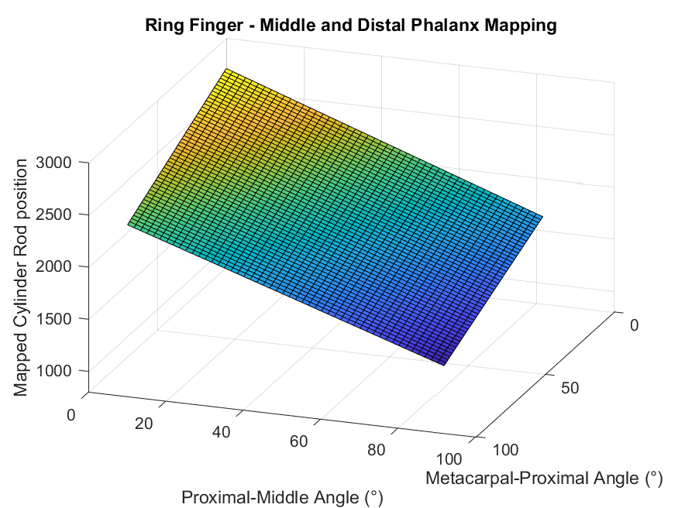

Figure 36 Linear position to PIP joint angle conversion formula for ring finger

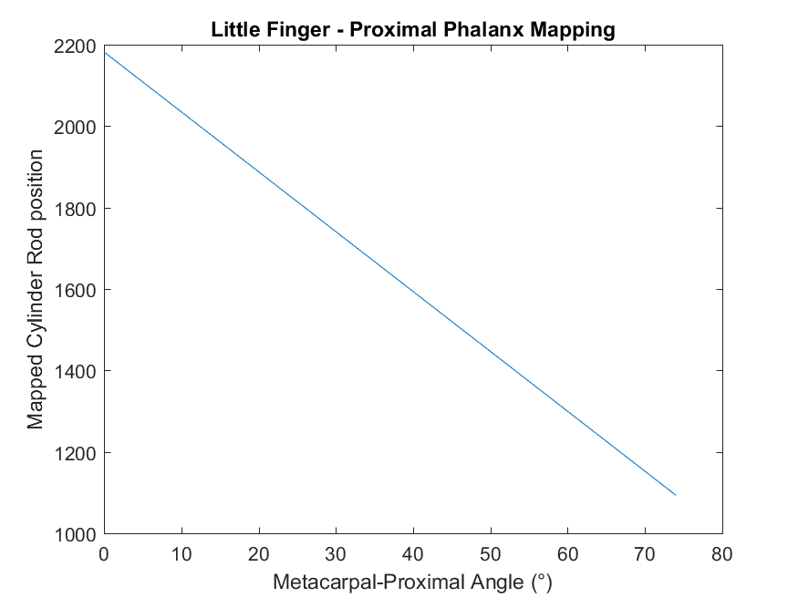

Figure 37 Linear position to MCP joint angle conversion formula for index finger

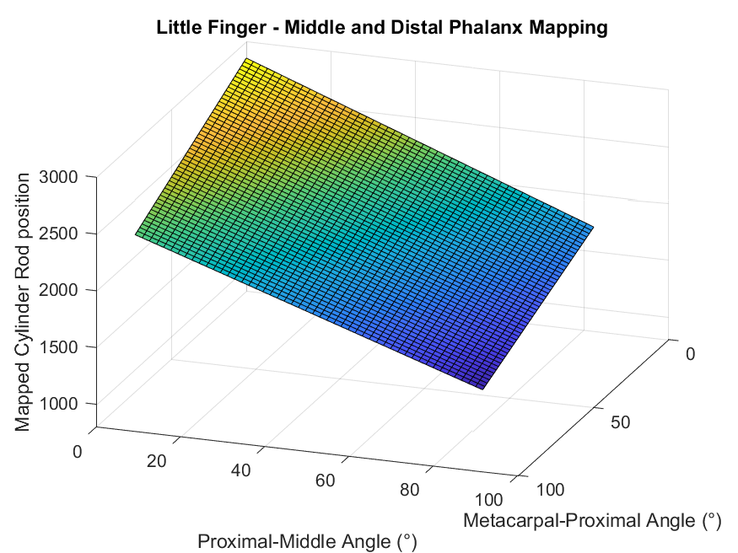

Figure 38 Linear position to PIP joint angle conversion formula for little finger

#### Appendix B – Hand Measurements and Poses

Table 9 Finger Dimensions for Model Analysis

|  |  |  |  |  |  |  |  |  |
| --- | --- | --- | --- | --- | --- | --- | --- | --- |
| **Finger** | **r1 (m)** | **R1 (m)** | **r2 (m)** | **R2 (m)** | **Ɵh1 (°)** | **Ɵg1 (°)** | **Ɵh2 (°)** | **Ɵg2 (°)** |
| Index | 0.00777 | 0.0509 | 0.00825 | 0.0181 | 19.6 | 8.3 | 30 | 16.6 |
| Middle | 0.009675 | 0.0539 | 0.008205 | 0.0169 | 0 | 0 | 7 | 3 |
| Ring | 0.008385 | 0.0526 | 0.008235 | 0.018 | 12.4 | 16.7 | 0 | 6.3 |
| Little | 0.008385 | 0.0502 | 0.00786 | 0.021 | 34 | 26.7 | 23 | 18 |

#### Appendix C – Hydraulic Schematic

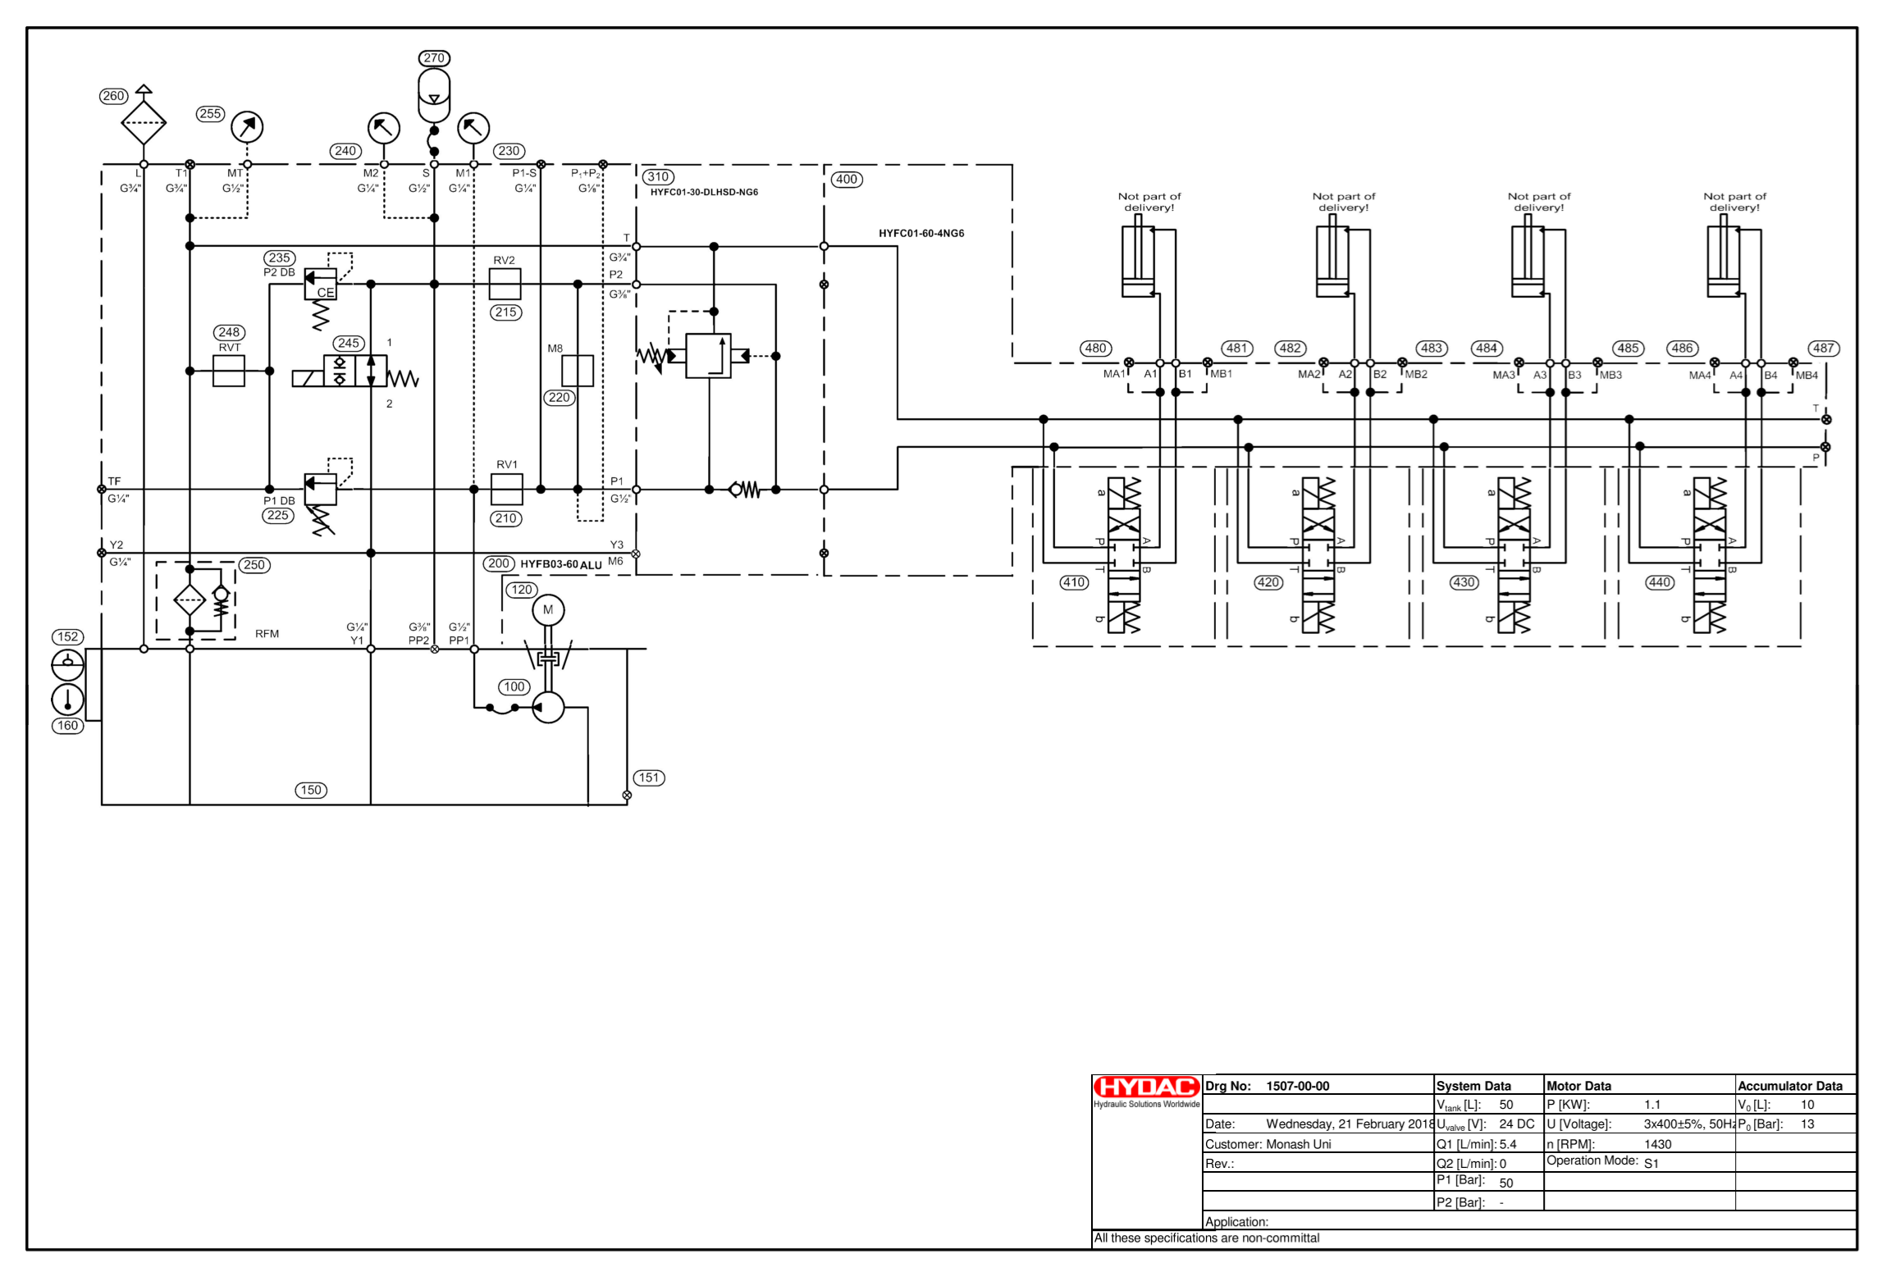

Figure 39 Complete hydraulic schematic

1. Repository can be accessed at: https://github.com/andrewmrobinson/Hydraulic-Mimic-Arm
2. https://github.com/andrewmrobinson/Hydraulic-Mimic-Arm/tree/master/Grip%20Videos